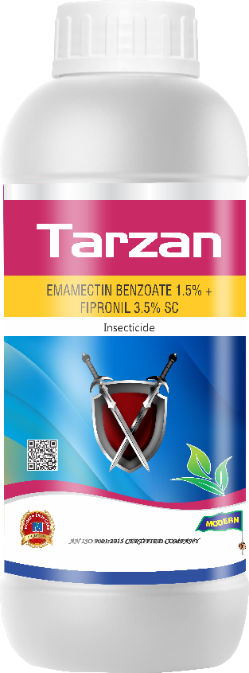
Product Name :- TARZAN
Technical Name :- Emamectin Benzoate 1.5% + Fipronil 3.5% SC
Description :- Tarzan Insecticide is a potent agricultural solution, formulated with the perfect combination of Emamectin Benzoate and Fipronil. It's designed to offer enhanced protection for a range of crops from harmful pests.
Packing :- 500ml, 1ltr
Crops :- Chili, Cotton, Cumin, Onion, and Garlic.

Disease/Pests :- The insecticide specifically targets Thrips and Fruit borers. These pests, both sucking and chewing types, pose a significant threat to the yield and quality of crops.

